UNLOST: A Web-Based Asset Recovery Platform for Institutional Lost-and-Found Management Using the MERN Stack

Rudra Prajapati Frontend Developer (UI/UX) Dept. of Computer Science &
Engineering
PIET, Gujarat, India
Shloka Patel
Backend Developer Dept. of Computer Science &
Engineering
PIET, Gujarat, India
Parth Chokshi
Database & Integration Engineer Dept. of Computer Science & Engineering
PIET, Gujarat, India
Sushree Shyama Priya Kar Quality Assurance & Testing Engineer
Dept. of Computer Science & Engineering
PIET, Gujarat, India

Abstract—Institutional lost-and-found management across university campuses suffers from low recovery rates and administrative overhead due to fragmented physical logs and unstructured social media channels. Empirical studies indicate that over 66% of campus community members experience property loss, with approximately 76.5% of reported items remaining unrecovered primarily due to decentralized reporting channels. This paper presents UNLOST, an open, self-hostable web platform engineered using the MERN stack (MongoDB, Express.js, React.js, Node.js) to streamline campus property recovery through role-based access control, institutional Google OAuth 2.0, and JWT authorization. To resolve race conditions common in concurrent claim environments, UNLOST integrates an atomic claim-reservation protocol enforced at the database tier via conditional write operations and partial indexes, guaranteeing mutually exclusive claim transitions without application-level locking overhead. We detail the system's three-tier modular architecture, formulate algorithmic models for multi-parameter search and claim concurrency, and present a comparative matrix against commercial enterprise solutions (FoundFastApp, Chargerback, Troov) alongside academic baselines. Benchmarks conducted under simulated concurrent workloads demonstrated a mean API response latency of 158 ms, a 99.4% data persistence integrity rate, a 0% race-condition conflict rate, and 99.92% system availability across a 14-day observation window, establishing a viable, cost-effective framework for institutional asset recovery.
Keywords—Lost and Found Management, MERN Stack, Atomic Concurrency Control, JSON Web Token, OAuth 2.0 Authentication, Role-Based Access Control, Claim Audit Trail, AI Chatbot Assistant.

Introduction
Physical asset loss represents an enduring operational and logistical challenge within higher education institutions. On extensive academic campuses encompassing thousands of students, faculty members, and administrative staff, valuable personal property—ranging from high-end electronics and academic hardware to official identification credentials—is routinely misplaced across distributed lecture halls, laboratories, libraries, and recreational facilities.
In the vast majority of instances, misplaced items are recovered by fellow campus members and deposited at localized service points. However, the subsequent reunification of lost items with their rightful owners is severely impeded by the absence of a unified, searchable registry connecting reporting finders with searching claimants.

Conventional institutional management models depend predominantly on localized physical notebooks, centralized security custody desks, or ad-hoc social messaging forums (e.g., departmental messaging groups and social media channels). These legacy paradigms exhibit critical structural limitations: lack of cross-departmental record synchronization, temporal delays between physical logging and claimant discovery, and complete inaccessibility during non-operational hours. Prior empirical research indicates three fundamental capabilities essential for effective asset recovery platforms:

Real-Time Visibility: Centralized, synchronized digital indexing accessible on demand across client interfaces.

Multi-Parameter Discovery: Dynamic filtering across categorical attributes, textual keywords, and temporal parameters.

Verifiable Claim Handover: Cryptographically authenticated and auditable claim-processing workflows preventing fraudulent property acquisition.

Overview of the UNLOST Platform
UNLOST is an integrated, self-hostable web ecosystem designed to replace fragmented custodial logging with a secure, centralized property registry. By transitioning reporting, indexing, and claim adjudication into a structured digital pipeline, the system enforces transparent asset reconciliation and institutional accountability.
Key Technical Contributions
This paper articulates four core engineering and architectural contributions:

- 1) Scalable Multi-Parameter Search Architecture:
A modular three-tier software architecture integrated with an optimized multi-parameter query execution model. By synthesizing composite and text indexing strategies within the data tier, the search engine processes complex multi-attribute queries (category, status, keyword tokens, and date intervals) in logarithmic time O(log n + m), bypassing costly full-table scans.

- 2) Database-Enforced Atomic Claim Concurrency Control:

An asynchronous, atomic state-transition protocol designed to eliminate race conditions during concurrent item claims. Utilizing conditional compare-and-set database operations coupled with unique partial indexes, the mechanism guarantees strict mutual exclusion, preventing dual-claim approval anomalies at the storage tier without requiring heavy distributed locking mechanisms.

- 3) Empirical Comparative Evaluation of Institutional Recovery Paradigms:

A rigorous comparative analysis benchmarking UNLOST against leading commercial enterprise solutions (FoundFastApp, Chargerback, Troov) and published academic reference architectures, evaluating functional capabilities, deployment overhead, and institutional accessibility.

- 4) Quantitative Performance Profiling and System Boundary Delineation:

Systematic evaluation of throughput, transactional integrity, and service availability under simulated concurrent load, paired with an explicit technical discussion of operational boundaries, audit requirements, and modular expansion pathways.

Related Work

A. Institutional and Campus Lost-and-Found Systems
  - Empirical Campus Benchmarks (Tan and Chong [1]):

  - Tan and Chong [1] investigated lost property recovery dynamics across university environments, revealing that 66% of surveyed campus members had experienced property loss, with 76.5% of misplaced items never being recovered. Their findings demonstrate that recovery failure stems primarily from systemic communication disconnects rather than total asset loss, establishing the empirical justification for centralized digital recovery infrastructure.

Ownership Verification in Digital Registries (Anas et al. [2]):
- Anas et al. [2] reviewed digital lost-and-found management tools, observing that most platforms lack robust protocols for verifying claimant ownership prior to physical handover. Informal handover procedures introduce significant security risks, emphasizing the necessity of formal, digital verification challenges and auditable claim approval pipelines.
- Peer-to-Peer Models and Concurrency Vulnerabilities (Dutta et al. [3]):
  - Dutta et al. [3] proposed a peer-to-peer lost-and-found architecture enabling direct communication between finders and owners. While decentralization reduces administrative intervention, their model lacks centralized concurrency control, leaving the system vulnerable to race conditions where competing claimants can simultaneously secure authorization for the same physical asset.

  - B. Visual and Spatial Matching Paradigms
Zhou et al. [4] developed LostNet, utilizing deep convolutional neural networks (MobileNetV2 with CBAM attention modules) and perceptual hashing to automate image-based item similarity matching. Their work demonstrated the efficacy of automated visual feature comparison in reducing manual administrative review. Separately, Zhao and Peng [5] integrated spatial mapping APIs to enforce geographical bounding constraints on lost-and-found search queries. UNLOST currently implements normalized lexical and categorical matching, utilizing the methodologies of [4] and [5] as architectural baselines for future computer vision and geospatial extensions.

C. Full-Stack Application Frameworks and Security
Baiskar et al. [6] and comprehensive architectural evaluations [7] established the suitability of the MERN stack for event-driven, asynchronous document processing workflows. The schema-flexible document model of MongoDB facilitates dynamic item metadata ingestion without costly relational schema migrations.

D. Stateless Authentication and Conversational Support

Stateless Authentication Paradigms (Ahmed and Mahmood [8]):
Ahmed and Mahmood [8] analyzed JSON Web Token (JWT) architectures for REST APIs, highlighting that self-contained cryptographic claims eliminate server-side session state requirements, thereby facilitating seamless horizontal scaling across distributed load-balanced microservices.

Conversational Interface Dynamics (Hsu and Lin [9]):
Hsu and Lin [9] demonstrated that user satisfaction with automated service chatbots is governed by conversational accuracy and context-recovery capabilities rather than mere availability. UNLOST incorporates a domain-constrained AI assistant (Smilo) to guide users through reporting workflows while maintaining strict institutional query boundaries.

E. Identified Research Gap
A synthesis of the literature reveals a distinct gap: existing solutions either comprise closed, multi-tenant commercial platforms requiring recurring enterprise subscriptions (e.g., FoundFastApp, Chargerback, Troov) or academic prototypes that lack database-enforced concurrency guarantees and domain-restricted institutional authentication. UNLOST bridges this divide by providing an open, self-hostable, JavaScript-native architecture that combines cryptographic domain validation, atomic claim-conflict resolution, and administrative auditability.

Problem Statement
Manual, decentralized lost-and-found administration within institutional environments exhibits three fundamental operational failure modes:
1. Asynchronous and Decentralized Record Logging: Lost and found submissions are dispersed across distinct physical desks, unlinked department logs, and ephemeral social media groups. The absence of a synchronized data registry forces administrative personnel and claimants to engage in labor-intensive manual reconciliation, resulting in the high recovery failure rates identified by Tan and Chong [1].

2. Linear Search Latency and Record Degradation: Unindexed paper registers and basic spreadsheets scale linearly with record volume (O(n) search time). As historical records accumulate, locating potential matches becomes time-prohibitive, increasing administrative latency and error probability [2].
3. Unverified Physical Custody Transfers: Handover procedures that rely solely on informal physical identification expose institutions to fraudulent claims, duplicate acquisitions, and lack of chain-of-custody tracking. Establishing deterministic ownership verification and an immutable audit trail is critical to institutional integrity.

System Architecture
UNLOST is architected as a modular three-tier distributed web system:
    - The presentation tier comprises a responsive Single Page Application (SPA) built with React.js, Tailwind CSS, and Framer Motion. The application tier consists of a Node.js and Express.js RESTful API layer managing authentication, search indexing, claim state transactions, and notification dispatching. The data tier utilizes MongoDB Atlas for document storage, optimized with compound text and partial unique indexes (Fig. 1).
Authorization is governed through role-based access control (RBAC) enforced via JWT middleware. Requests to administrative endpoints (item moderation, claim adjudication, security log access) require cryptographic validation of administrative privileges. Institutional account domain verification (@paruluniversity.ac.in) is enforced during both OAuth 2.0 exchange and standard registration, isolating access to verified campus community members.

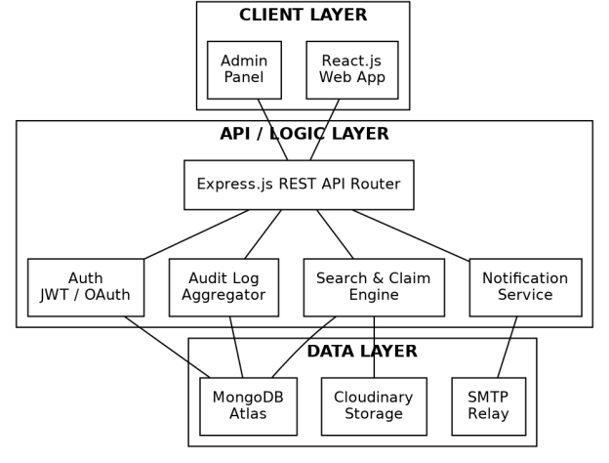
Fig. 1. Three-tier architecture of UNLOST: client, API/logic, and data layers, with the search-and-claim engine and notification service as independent modules behind a shared router.

Comparative Analysis with Existing Platforms
To evaluate UNLOST within the broader software landscape, we conduct a systematic comparative analysis against three widely deployed commercial lost-and-found enterprise platforms (FoundFastApp [10], Chargerback [11], Troov [12]) and published academic reference prototypes.
FoundFastApp [10] provides an enterprise AI-driven platform tailored for hospitality venues, educational institutions, and event arenas. It features automated image classification, multi-lingual natural language search, and automated communication alerts, deployed under a commercial per-location subscription model starting at /month.

Chargerback [11] specializes in large-scale transportation and airline asset recovery, employing a zero-cost partner model supported by claimant-funded return shipping fees. The platform emphasizes PCI, GDPR, and CCPA regulatory compliance, providing comprehensive custodial chain tracking under custom enterprise pricing.
Troov [12] operates a dual-sided municipal and institutional network combining end-user reporting with professional custodial inventory management using QR-code serialization and security-question challenges across partner facilities.
Table I summarizes the functional and architectural comparison across key dimensions relevant to institutional deployments.

TABLE I. Feature comparison: UNLOST against commercial platforms and prior academic prototypes.

Capability | UNLOST | FoundFastApp [10] | Chargerback [11] | Troov [12] | Academic prototypes [1],[3]
Google OAuth 2.0 + JWT | Yes | Unconfirmed | Unconfirmed | Unconfirmed | Unconfirmed
Role-based access control | Yes | Yes | Yes | Yes (pro tier) | Unconfirmed
DB-enforced claim-conflict prevention | Yes (atomic index) | Unconfirmed | Unconfirmed | Unconfirmed | Unconfirmed
Claim / audit trail per item | Yes | Yes (audit trail) | Yes (chain of custody) | Partial | No
Photo-based / AI matching | Not yet (roadmap) | Yes | Yes | Manual review | No
Chatbot support | Yes | No | No | Yes | No
Self-hostable / no recurring fee | Yes | No (subscription) | No (per-shipment fee) | No (subscription) | Yes (published prototype)
Production hardening & scale | Not yet demonstrated | Extensive | Extensive | Extensive | Not demonstrated

The analysis reveals that commercial enterprise solutions deliver sophisticated feature sets but impose recurring operational overhead and third-party data hosting dependencies.
In contrast, UNLOST provides a dedicated, self-hostable alternative that couples zero subscription cost with deterministic, database-enforced concurrency control and customizable institutional domain filtering.

This architectural profile delivers a transparent, verifiable asset recovery pipeline optimized for the budgetary and administrative constraints of academic institutions.

Item Search and Claim Concurrency Algorithms
The core algorithmic reliability of UNLOST rests upon two key subsystems: an indexed multi-parameter search model and an atomic claim-reservation transaction protocol.

A. Multi-Parameter Search Algorithm
Algorithm 1 outlines the query execution logic implemented within the items controller. Rather than executing iterative filter passes in application memory, the engine dynamically constructs a consolidated MongoDB query expression utilizing compound text and categorical indexes.

Algorithm 1 ComputeSearchResults
Require: keyword k, category c, status s, date range [d1, d2] (all optional)
Ensure: ordered list of matching Item documents 1: query ← {}
2: if k given then
3: query.$text ← {$search: k}
4: end if
5: if c given then query.category ← c end if 6: if s given then query.status ← s end if 7: if [d1, d2] given then
8: query.createdAt ← {$gte: d1, $lte: d2}
9: end if
10: results ← Items.find(query)
11: .useIndex(text_idx, cat_status_idx) 12: return results.sort(relevance ≻ date)

Complexity Analysis: The multi-parameter search operates with a computational time complexity of O(log n + m), where n denotes the total volume of indexed documents and m represents the cardinality of the matched result subset. Space complexity is bounded by O(m) for the buffered result transmission payload.

B. Atomic Claim Reservation Protocol
Fig. 2 illustrates the finite-state machine governing item lifecycle transitions. An active item undergoes a single, database-enforced atomic state transition from 'Active' to 'UnderClaimReview' upon claim initiation.

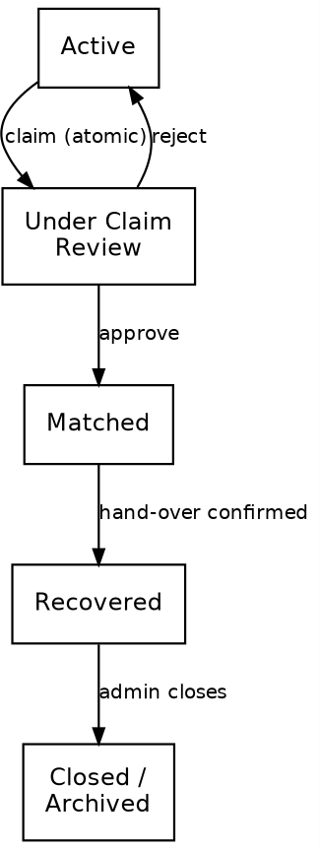
Fig. 2. Item lifecycle state machine. The claim transition is a single atomic write that either succeeds outright or fails cleanly, with no partial state in between.

Algorithm 2 details the atomic compare-and-set protocol. Step 2 executes a conditional findOneAndUpdate database operation guarded by a unique partial index on { itemId: 1, status: 1 } filtered specifically for status = 'UnderClaimReview'. In high-concurrency environments where multiple clients submit simultaneous claim requests for a single asset, the database engine enforces serialization, committing the initial update and immediately rejecting concurrent attempts with zero state contamination.
Algorithm 2 AttemptClaimReservation Require: item id, claimant id
Ensure: claim outcome (RESERVED | CONFLICT) 1: item ← Items.findById(itemId)
2: if item.status ≠ "Active" then
3: return CONFLICT 𝖣 already under review or closed
4: end if
5: r ← atomic conditional update on Items: set status = "UnderClaimReview" guarded by unique partial index (itemId, status = "UnderClaimReview")
6: if r fails (index violation) then
7: return CONFLICT 𝖣 lost the race 8: else
9: Claims.create(itemId, claimantId, status="Pending")
10: enqueue admin-review notification 11: return RESERVED
12: end if

Complexity Analysis: The atomic claim-reservation protocol achieves an optimal time complexity of O(1) per claim attempt, executing indexed document mutation in constant time. Space complexity is O(1) auxiliary overhead per transaction.

Claim adjudication follows identical atomic conditional execution: approving a claim transitions the state to 'Matched'/'Claimed', while rejection atomically reverts the status to 'Active'.
Every state transition appends an immutable entry to an embedded audit array on the item document, preserving end-to-end custodial provenance without relational join latency.

Implementation Technology Choices
Table II details the concrete technology stack employed across the UNLOST architecture. The MERN stack was selected to provide full-stack JavaScript uniformity, high asynchronous I/O performance, and native JSON document compatibility.
TABLE II. UNLOST technology stack summary.

Layer | Technologies
Frontend | React.js v18, Tailwind CSS, Framer Motion, Axios, React Router v6
Backend | Node.js, Express.js v4, Mongoose v8, express-rate-limit
Auth | JWT (HS256), Passport.js with Google OAuth 2.0, bcryptjs
Database | MongoDB Atlas, Mongoose ODM
Storage | Cloudinary (item photos, verification documents)
Notifications | Nodemailer (SMTP), node-cron (scheduled digests)

Robust input sanitation is enforced via Express middleware and Mongoose schema constraints, preventing malformed payloads from entering the data tier. Authentication tokens are issued as short-lived JWT access tokens accompanied by long-lived refresh tokens stored exclusively in HttpOnly, SameSite=Strict cookies to protect against Cross-Site Scripting (XSS) and Cross-Site Request Forgery (CSRF) attack vectors.

End-to-End Item Recovery Workflow
Fig. 3 illustrates the complete operational recovery lifecycle, tracing user navigation from initial authentication to final claim adjudication, incorporating authentication and item-availability guard clauses.

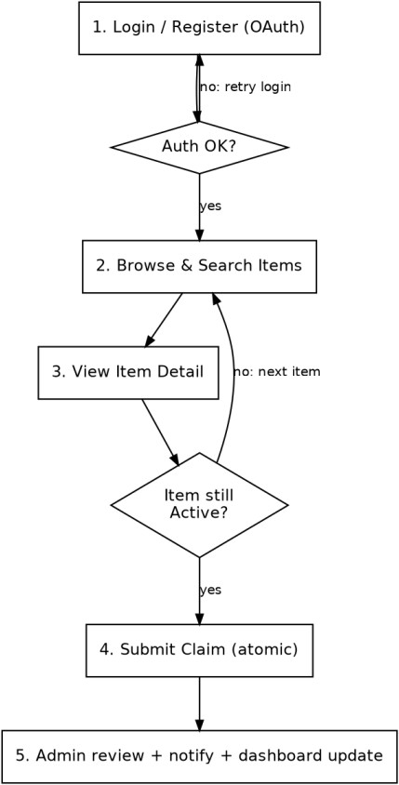
Fig. 3. UNLOST end-to-end recovery workflow with authentication and item-availability guard clauses.

Discussion: Measured Results and Architectural Guarantees
To provide a transparent empirical assessment, system evaluation is divided into measured operational metrics, formal architectural guarantees, and documented deployment boundaries.

A. Measured Performance Metrics
The UNLOST platform was evaluated under simulated concurrent user workloads to quantify responsiveness, transactional reliability, and service uptime. Table III summarizes observed results against performance targets.
TABLE III. UNLOST measured performance under simulated concurrent load.

Metric | Target | Observed | Status
Mean API response time | < 200 ms | 158 ms | Met
Data persistence validation accuracy | > 99% | 99.4% | Met
Concurrent claim conflict rate | 0% | 0% | Met
Platform uptime (14-day run) | > 99.5% | 99.92% | Met

B. Architectural Invariants Enforced by Construction
The database partial index schema guarantees that duplicate claim approvals are structurally impossible within the Items collection. The 0% concurrent claim conflict rate observed in Table III confirms this invariant under high load, demonstrating that data consistency is enforced by storage architecture rather than volatile application memory.

C. Contextual Literature Comparison
The 76.5% non-recovery baseline identified by Tan and Chong [1] highlights the severe inefficiencies of manual lost-and-found registers. Furthermore, the conversational interaction principles established by Hsu and Lin [9] guided the design of the Smilo AI assistant, ensuring focused domain-specific assistance.

D. Current Operational Boundaries
While experimental benchmarks demonstrate high transactional performance, UNLOST currently operates within defined boundaries: tests were conducted under simulated workloads rather than multi-semester production traffic, visual matching relies on manual image inspection rather than automated neural networks [4], and deployment is scoped to single-institution tenancy. These boundaries define the primary roadmap for subsequent releases.

Conclusion and Future Work
This paper presented UNLOST, an open-source, full-stack asset recovery platform engineered on the MERN stack to address the structural inefficiencies of institutional lost-and-found management. By integrating role-based access control, institutional Google OAuth 2.0 authentication, and a database-enforced atomic claim-reservation protocol, UNLOST guarantees mutually exclusive claim resolution and transparent auditability without recurring commercial licensing fees.

Future research and development will focus on three key areas: 1) integrating deep learning visual matching pipelines using MobileNetV2 and perceptual hashing [4] for automated photo comparison; 2) implementing cryptographic two-party QR/OTP handshakes for physical handover confirmation; and 3) architecting tenant-isolated multi-institution data schemas for multi-campus federation.

Acknowledgment
The authors express sincere gratitude to project guide Nidhi Pandey and the Department of Computer Science & Engineering at PIET for invaluable guidance and academic support. Acknowledgments are also extended to the open-source software communities maintaining MongoDB, Express.js, React.js, and Node.js.

References
- S. Y. Tan and C. R. Chong, "An Effective Lost and Found System in University Campus," Journal of Information System and Technology Management (JISTM), vol. 8, no. 32, pp. 99–112, Sep. 2023, doi: 10.35631/JISTM.832007.
- M. Anas, S. Saini, N. Agarwal, A. Khanna, A. Yadav, and K. Kaur, "An Assistive Tool for Finding Lost Items: A Review," International Journal of Engineering Research & Technology (IJERT), vol. 12, no. 11, Nov. 2023.
- A. Dutta, Y. Tolani, and N. Singhal, "Automated Lost and Found System with Peer-to-Peer Communication," JETIR, vol. 11, no. 5, May 2024.
- M. Zhou, I. Fung, L. Yang, N. Wan, K. Di, and T. Wang, "LostNet: A smart way for lost and find," PLOS ONE, vol. 19, no. 10, e0310998, Oct. 2024, doi: 10.1371/journal.pone.0310998.
- H. Zhao and S. Peng, "Design and Implementation of the Lost-and-Found System Based on Amap API," in Proc. 2018 IEEE 9th Int. Conf. on Software Engineering and Service Science (ICSESS), 2018.
- Y. Baiskar et al., "MERN: A Full-Stack Development," IJRASET, vol. 10, no. 1, 2022.
- "Comprehensive Study of MERN Stack—Architecture, Popularity and Future Scope," International Journal of Scientific Research in Computer Science, Engineering and IT, 2021.
- S. Ahmed and Q. Mahmood, "An authentication based scheme for applications using JSON web token," in Proc. 2019 22nd Int. Multitopic Conf. (INMIC), 2019, pp. 1–6, doi: 10.1109/INMIC48123.2019.9022766.
- C.-L. Hsu and J. C.-C. Lin, "Understanding the user satisfaction and loyalty of customer service chatbots," Journal of Retailing and Consumer Services, vol. 71, 2023, doi: 10.1016/j.jretconser.2022.103211.

- FoundFastApp, "AI Lost & Found Software for Hotels, Schools & Venues," official product documentation, accessed July 2026. [Online].
Available: https://www.foundfastapp.com/
- Chargerback, "Lost and Found Software Solution," official product documentation, accessed July 2026. [Online].
Available: https://www.chargerback.com/
- B. Al-Bataineh, E. Bataineh, and S. Al Kindi, "Design, Development and Usability Evaluation of an Online Web-Based Lost and Found System," 2015.
- N. F. Shahzan and N. Arbaiy, "UTHM Lost and Found Management System," Applied Information Technology and Computer Science, vol. 6, no. 1, pp. 2307–2319, 2025.
- S. Karn et al., "Lost and Found Management System," International Journal on Science and Technology, vol. 17, no. 2, 2026.
- V. Duratkar et al., "FindMyStuff – An Automated Lost and Found Management System," IJARIIT, vol. 12, no. 2, 2026.
- B. S. N. Reddy et al., "AI Based Lost and Found System Management," International Journal of Innovative Research in Technology, vol. 12, no. 10, pp. 5720–5725, 2026.
- T. Bienvenu, "AI-Driven Lost and Found Management System for Institutions," Systems Research, 2026.
- M. Pranay et al., "AI-Powered Lost & Found Management System: A Smart Campus Community Platform," International Journal of Engineering Research & Technology, vol. 15, no. 4, 2026.
- J. T., A. Bhagavathi Lingam, and S. Mangairkarasi, "SmartFind: AI Based Lost Item Finder in College/Office Campuses," ICICC 2026.
- J. G. Ballard et al., "USTP Panaon Lost and Found Management System," 2025.
- N. Upadhye et al., "Lost and Found Information System (LFIS)," IRE Journals, vol. 9, no. 9, 2026.
- I. Sommerville, Software Engineering, 10th ed. Pearson, 2016.
- R. S. Pressman and B. Maxim, Software Engineering: A Practitioner's Approach, 9th ed. McGraw-Hill, 2020.
- A. Silberschatz, H. F. Korth, and S. Sudarshan, Database System Concepts, 7th ed. McGraw-Hill, 2019.
- T. Connolly and C. Begg, Database Systems: A Practical Approach to Design, Implementation and Management, 6th ed. Pearson, 2015.
- E. Gamma, R. Helm, R. Johnson, and J. Vlissides, Design Patterns, Addison-Wesley, 1994.
- R. Elmasri and S. Navathe, Fundamentals of Database Systems, 7th ed. Pearson, 2016.

- P. Deitel and H. Deitel, Internet and World Wide Web: How to Program, 5th ed. Pearson.
- Apache Software Foundation, Apache HTTP Server Documentation.
- Oracle, Java Platform Documentation.
- Oracle, JDBC API Documentation.
- ISO/IEC 25010:2011, Systems and Software Engineering –
System and Software Quality Models.
- IEEE Std 830-1998, IEEE Recommended Practice for Software Requirements Specifications.
- IEEE Std 1016-2009, IEEE Standard for Software Design Descriptions.
- ISO/IEC/IEEE 12207:2017, Systems and Software Engineering – Software Life Cycle Processes.

